**DBMS PROJECT REPORT**



**GROUP MEMBERS:**

**MINAHIL OVAIS - SE 003  
HASHIR TIHAMI – SE 065**

**ENHANCED ENTITY RELATIONSHIP DIAGRAM:**

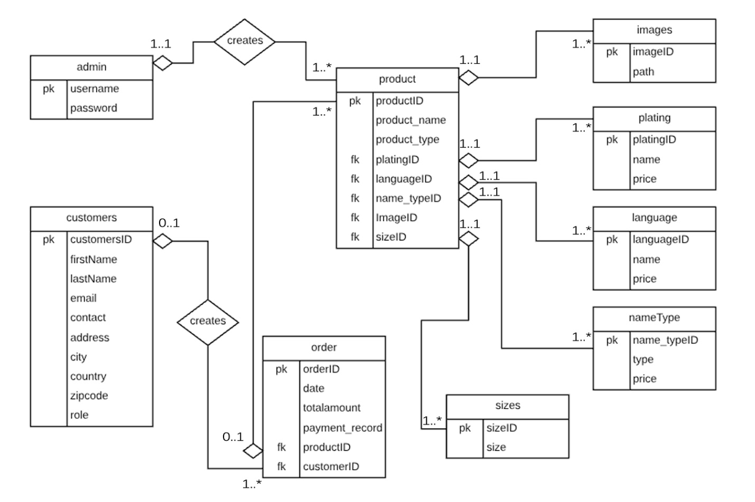

**NORMALIZATION PROCESS:**

Unnormalized Form:





1nf:   
-Each cell to be single valued  
-Entries in a column are same type  
-Rows uniquely identified by adding a unique ID or more columns to make it unique

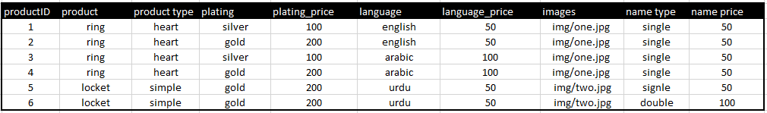



2nf:

-It must fulfil the requirements of first normal form.

-All attributes (non-key columns) dependent on the key

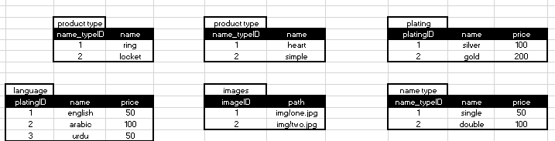



Example Queries:

CREATE TABLE `category` (

`categoryID` int(11) NOT NULL,

`category` varchar(10) DEFAULT NULL) ENGINE=InnoDB DEFAULT CHARSET=latin1;

INSERT INTO `category` (`categoryID`, `category`) VALUES

(1, 'Bracelet'), (3, 'Cufflinks'), (6, 'Earring'), (4, 'Locket'), (2, 'Ring');

INSERT INTO `customer` (`customerID`, `first_name`, `last_name`, `email`, `password`, `hash`, `contact`, `active`, `address`, `city`, `zipcode`, `country`, `role`) VALUES

(1, 'Hashir', 'Tihami', ‘something@gmail.com’, '$2y$10$4Ax.jnTWQOwIJDhdVanbY.9L2ME9mM/iljrrgCJ3SK00O97n0nrJG', 'ac1dd209cbcc5e5d1c6e28598e8cbbe8', '+923158257773', 0, 'H#l87, Sector 5l, north karachi', 'Karachi', 75850, 'Pakistan', 'customer'),